Graduation Rate Influencers
Ashley E Hunter
Western Governors University

Table of Contents
A. Project Highlights 4
B. Project Execution 13
C. Data Collection Process 13
C.1 Advantages and Limitations of Data Set 14
D. Data Extraction and Preparation 15
E. Data Analysis Process 19
E.1 Data Analysis Methods 19
E.2 Advantages and Limitations of Tools and Techniques 29
E.3 Application of Analytical Methods 34
F Data Analysis Results 36
F.1 Statistical Significance 36
F.2 Practical Significance 40
F.3 Overall Success 42
G. Conclusion 42
G.1 Summary of Conclusions 42
G.2 Effective Storytelling 45
G.3 Recommended Courses of Action 49
H Panopto Presentation 51
References 52
Appendix A 53
Visualizations 53
Appendix B 57
Code Access 57

A. Project Highlights
Research Question: Do teacher working hours, class size, and education expenditures have a significant impact on graduation rates in G20 countries?
The research question addressed a fundamental concern in education policy: identifying which factors most significantly influence graduation rates. Understanding these relationships is crucial for policymakers, as they have the authority to allocate limited resources efficiently. While instinct suggests that smaller class sizes, longer teacher workdays, and higher education spending should improve graduation rates, empirical evidence remains mixed and often contradictory. This analysis provides quantitative evidence to inform decisions on resource allocation and educational reform initiatives.

Included in Project Scope
The analysis includes three G20 countries: Germany, France, and the United Kingdom. These countries were selected based on data availability and represent advanced economies with well-established education systems that provide reliable, comparable data across all required variables.
The study examines three consecutive years of 2017, 2018, and 2019. The timeframe was determined by data availability, specifically the completeness of teacher working hours data during the years. The three-year period provides sufficient time variation to observe patterns while maintaining data quality and consistency.
This analysis includes four key variables: secondary education graduation rates, teacher working hours, class size, and education expenditures. The dependent variable is graduation rates, which are measured as the percentage of students completing upper secondary education. Teacher working hours (an independent variable) are measured as annual statutory working time for upper secondary teachers. Another independent variable, class size, is measured as the average number of students per class in lower secondary education (used as a proxy for secondary education due to data availability). The last independent variable is government education expenditure as a percentage of GDP.
The project uses publicly available data from three reliable sources: OECD Education at a Glance, World Bank Education Statistics, and UNESCO Institute for Statistics. OECD Education at a Glance provided datasets for teacher hours and class size. World Bank Education Statistics provided the dataset for expenditure data. UNESCO Institute for Statistics provided the dataset for graduation rates.
Five different analytical methods were used in this project. Descriptive statistics are used to characterize the distribution of variables. Next, correlation analysis is used to examine paired relationships, and multiple linear regression is used to test the relationships between factors and graduation rates. Diagnostic testing was also used to verify regression assumptions, and visualization techniques were employed to effectively communicate the findings.
The project included five different levels of analytical depth. There are quantitative estimates of relationships between factors and graduation rates, and statistical significance testing for the overall model and individual coefficients is present. An assessment of the practical significance and policy implications is also present, along with two evidence-based recommendations for education policymakers. Finally, the limitations and suggestions for future research are presented at the end of this report.
Five deliverables are included in this project: a cleaned, merged dataset taken from the original raw datasets for analysis in CSV format, Python scripts for data cleaning and statistical analysis that are documented and version controlled, six visualizations illustrating distributions, relationships and diagnostics results, written reports documenting methodology, findings and policy recommendations and finally, a video presentation demonstrating code execution and explaining results via Panopto.

Not included in Project Scope
The analysis does not include all G20 countries. While the original concept considered analyzing all 19 G20 countries, data availability constraints, specifically incomplete teacher working hours data for most countries, led to limiting the scope to three countries with complete data. Expanding beyond these three countries would compromise data quality and introduce missing values, potentially biasing the results.
Time-series methods were not employed in this project, nor were panel data techniques or long-term trend analysis. The three-year timeframe is insufficient for rigorous time-series modeling, and the small number of observations precludes the use of advanced longitudinal methods, such as fixed-effects or random-effects models.
The analysis does not establish causal relationships between factors and graduation rates. The cross-sectional, observational nature of the data limits conclusions to associations rather than causation. The project does not use experimental designs, instrumental variable approaches, regression discontinuity designs, or other causal inference techniques that would be necessary to make strong causal claims.
The project does not include qualitative variables such as curriculum quality, teaching methods, student motivation, socioeconomic factors beyond expenditure, cultural attitudes toward education, or details on policy implementation. While these factors undoubtedly influence graduation rates, they are difficult to quantify consistently across countries and are beyond the scope of available data.
The analysis does not break down education expenditure into specific categories, such as teacher salaries, infrastructure investment, instructional materials, technology spending, or administrative costs. While understanding how money is spent would provide valuable insights, such detailed financial data is not available in a standardized format across the three countries for this period of study.
The project does not examine regional variation within countries, differences across school types, or variation by student demographics. All data are national aggregates, and sub-national analysis would require different data sources, substantially expanding project complexity. The analysis acknowledges that national averages may mask important within-country variation.
The analysis does not investigate how policies are implemented, enforced, or received by stakeholders. For example, while teacher hours will be measured as statutory requirements, the analysis will not examine compliance rates, how teachers actually allocate their time, or whether contractual hours reflect actual work patterns. This will also apply to graduation rate policies at any level.
These exclusions were necessary to maintain project feasibility within the capstone timeframe and available resources. Attempting to include all relevant factors would have led to scope creep and potentially compromised the quality of the core analysis. By clearly defining what was not included, the project established realistic boundaries while acknowledging areas for future research.

Standard Methodology
This project employed an iterative, data-driven planning methodology that creates a balance between structure and flexibility. The approach followed a modified waterfall model, with each phase building on the previous one and built-in checkpoints to reassess and adjust as needed. The methodology emphasized early data exploration to identify potential challenges before committing to specific analytical approaches. This adaptive approach ensured that the analysis remained grounded in data reality rather than forcing inappropriate methods on incomplete data.
Risk management was used throughout the planning process. Early data collection mitigated data availability issues. Careful interpretation of results helped mitigate the limitations of a small sample size. Diagnostic testing helped with violations of regression assumptions, and time constraints were managed through a phased timeline with buffer periods.
The chosen methodology prioritized reproducibility and documentation. All data sources are publicly available and clearly cited. All analytical code was well commented and version-controlled. This approach ensured that findings could be independently verified and that the analysis could be extended by future researchers.

Tools, Languages, and Environments
The primary programming language for this project was Python 3.12 for all data manipulation, statistical analysis, and visualization. It was sourced from python.org, which is an open-source, freely available platform and the industry standard for data analytics, offering extensive statistical libraries and documentation. The version used ensured compatibility with all required packages and optimized performance. For this project, Python was used for data cleaning scripts, regression analysis, hypothesis testing, generating visualizations (Appendix A), and outputting results.
The IDE used in this project was PyCharm, which was used to write Python scripts, debug data-cleaning logic, test analysis functions, and manage project files. It is from JetBrains and was accessed through WGU. PyCharm was used for this project because it provides professional-grade development tools, including syntax highlighting, code completion, an integrated debugger, and Git integration, which improved code quality and development efficiency.
Seven third-party Python libraries were installed via pip (Python Package Index) and used throughout the project:
- Pandas 2.1.0 for data manipulation and analysis, because it is an industry-standard library for tabular data manipulation, essential for cleaning and preparing datasets from multiple sources.
  - Key functions used: read_csv() and read_excel() for loading datasets, merge() for combining datasets, groupby() for aggregating data by country and year, describe() for generating summary statistics, fillna() and dropna() for handling missing values, to_csv() for exporting a cleaned dataset.
- NumPy 1.24.0 for numerical computing and array operations, because it is the foundational library for such activities in Python, and it is also required by other scientific packages.
  - Key functions used: array operations for matrix calculations, statistical functions (mean, std, median), linear algebra operations for regression calculations, and random number generation for testing.
- Scikit-learn 1.3.0 for machine learning and statistical modeling, because the comprehensive machine learning library has strong regression implementations and model evaluation tools that are widely used in academic research.
  - Key components used: LinearRegression from sklearn.linear_model for fitting regression models, train_test_split from sklearn.model_selection for data splitting (if needed), StandardScaler from sklearn.preprocessing for feature scaling (if needed), r2_score, and mean_squared_error from sklearn.metrics for model evaluation.
- SciPy 1.11.0 for scientific computing and statistical tests, because it provides essential statistical tests not included in Python, required for hypothesis testing and model diagnostics.
  - Key modules used: scipy.stats.pearsonr for correlation coefficient calculation, scipy.stats.shapiro for normality testing for residuals, scipy.stats.f for F-distribution for F-test, scipy.stats.t for t-distribution for t-tests.
- Matplotlib 3.7.0 for data visualization (Appendix A) and plotting because it is the fundamental library for Python, and it provides control over visualization appearance for professional-quality graphics.
  - Key modules used: matplotlib.pyplot for creating figures and axes, line plots, scatter plots, histograms, figure formatting, and exporting to PNG format.
- Seaborn 0.12.0 for statistical data visualization (Appendix A) because it is a high-level library built on Matplotlib and simplifies the creation of complex statistical plots with professional-ready aesthetics.
  - Key functions used: heatmap() for correclation matrix visualization, regplot() for regression plots with confidence intervals, pairplot() for pairwise relationship visualization, set_style() for aesthetic themes.
- Openpyxl 3.1.0 for reading Excel files because it is required for reading OECD Excel files with a pure Python implementation that ensures cross-platform compatibility.
  - Key functions used: load_workbook() for opening Excel files, accessing specific sheets and cells, and reading OECD data files that come in .xlsx format.
There were two data management and documentation tools, two version control tools, a code repository tool, one quality assurance tool, and two tools for presentation and communication:
- Microsoft Excel, version included with Microsoft 365, for initial data inspection and validation because it is a familiar interface for initial data exploration, and it is compatible with OECD file formats.
  - Used cases: opening raw OECD Excel files, quick data preview, and verifying data structure before Python processing.
- Microsoft Word, version included with Microsoft 365, for documentation writing and formatting because it is the industry-standard word processor and provides APA formatting tools.
  - Used cases: writing Task 2 proposal, writing Task 3 final report, formatting documents in APA style.
- Git 2.40.0 for version control of code written during the project because it is the industry-standard for version control and essential for reproducible research and professional code management.
  - Used cases: backing up code, sharing a project publicly, and creating a professional portfolio for job applications.
- GitHub for remote repository hosting and project portfolio because it is the industry-standard platform.
  - Used cases: backing up code, sharing a project publicly, and creating a professional portfolio for job applications.
- Grammarly for grammar checking and writing enhancement because it will improve the written deliverables.
  - Used cases: proofreading Topic Approval, Task 2, and Task 3 documents, identifying grammatical errors, and improving writing clarity.
- Panopto for video recording and hosting for the final presentation because it is the platform required by the capstone for Task 3 video submission.
  - Used cases: recording the capstone presentation video, demonstrating code execution, and explaining findings.
- WGU Student Portal for course access and submission of Topic Approval, Task 2, and Task 3, including the video, because that is what is required of the capstone.
The laptop that was used had sufficient RAM, processor, storage, and operating system
to perform the necessary analysis without any issue. The installation and setup process for the required environment involved installing all Python packages with pip, ensuring consistent package versions, and properly managing dependencies. All third-party libraries used in this project are open source and properly licensed for academic research; no proprietary or restricted code was used. This toolset provided all necessary capabilities for data acquisition, cleaning, analysis, visualization, and documentation while maintaining professional standards for reproducing the research.

B. Project Execution
- The project plan
The project plan was carried out as outlined in Task 2. All data mentioned in the proposal were collected, and the reason for the small sample set was confirmed.
- The project planning methodology
There were no variances from the planned methodology stated in Task 2. The modified waterfall approach with built-in checkpoints functioned exactly as intended, allowing the change from the topic approval to the stated plan in Task 2 to be confirmed without interference.
- Project timeline and milestones
The timeline and milestones mentioned in Task 2 had minor adjustments. These adjustments were positive ones and made possible by having more time after losing my job; therefore, I was able to devote all my time to completing the analysis and writing the reports.

C. Data Collection Process
- How the data selection and collection differed from your plan
The data selection and collection procedures stated in Task 2 for this project did not deviate from what was discussed.
- How you handled any obstacles encountered while collecting your data.
Several of the possible challenges mentioned were encountered, such as website navigation, as these organizations have vast databases with many articles and reports. This obstacle was overcome by taking the time to experiment with various keyword searches until the correct datasets were found. Another obstacle was delays in availability, as the original Topic Approval differed from what was stated in Task 2, and why. This was overcome by adjusting the scope while still maintaining the overall idea and goal.
- How you handled any unplanned data governance issues.

There were no unplanned data governance issues during data collection for this project. All data sources are publicly available with no proprietary or confidential information used. Because the organizations that provided the datasets were internationally known for their strict data standards, all data were considered reliable and available for reproduction if necessary.

C.1 Advantages and Limitations of the Data Set
One advantage of the datasets collected is that they come from organizations with international reputations and strict standards for data collection and reporting. An example of this would come from the dataset on teacher working hours from OECD – the framework used in that report, known as the International Standard Classification of Education, meaning that the measurements are consistent across all countries. Another advantage would be the timing consistency – avoiding the COVID-19 Pandemic, which certainly affected school systems worldwide and would have resulted in abnormal results at an abnormal time; with consecutive years leading up to 2020, patterns were observed which aided in regression analysis.
One obvious limitation is the small sample size in this project. There are only 9 observations, which limits statistical power and the ability to detect relationships between variables, and the regression model has limited degrees of freedom. For example, with 9 observations, that would equal 4 degrees of freedom, meaning that if one of the countries had any unusual values during the time period, it could disproportionately influence the test results. Another limitation is the limited years covered; to detect any long-term trends, the year coverage would need to be longer. For example, if any of the chosen countries had made infrastructure or policy changes related to education in the years prior to 2017, this project would only be seeing the early results of those changes, not their long-term effects.

D. Data Extraction and Preparation
Extraction
The data extraction process involved obtaining data from three distinct international sources, each requiring a different extraction approach based on its delivery format and structure.
OECD Education at a Glance Data (Teacher Working Hours and Class Size) Extraction
  - Provided as downloadable Excel files through OECD’s “Education at a Glance” publication repository (files for 2018, 2019, and 2020 due to the one-year publication delay). It required navigating to specific indicator tables within multi-tab workbooks and identifying the relevant education level, country rows, and year columns.
  - Manual extraction was then followed for all values needed for Germany, France, and the United Kingdom, and was appropriate due to the extensive data points included in the file referencing other factors that were not relevant to this analysis.
UNESCO Institute for Statistics Data (Graduation Rates) Extraction
- This dataset was accessed through the UIS.Stat data portal that has an interactive web-based query interface. The dataset was downloaded as a CSV file for all three countries for 2017 – 2019.
- This extraction was appropriate because UNESCO’s interface is specifically designed for custom queries, allowing efficient filtering to the exact needed indicator, countries, and years without downloading irrelevant data.
World Bank Education Statistics (Government Expenditure on Education) Extraction
- The data was accessed through the World Bank Open Data portal’s API and bulk download options in a CSV file format.
- The bulk download option was a result of the World Bank’s simple data structure, making it more appropriate to go this route and then clean the dataset in Python rather than performing specific filtering steps similar to UNESCO.
Tools Used for Extractions
- Web browser: I used Chrome to navigate data portals and download data files.
- Microsoft Excel: To open OECD workbooks, navigate multi-tab structures, and verify data before extraction.
- Data portal interfaces: OECD iLibrary, UNESCO UIS.Stat, World Bank Open Data portals
Appropriateness of Extraction Methods
The combination of manual and automated extraction methods was appropriate given the characteristics of the data sources. This mixed-method approach balanced efficiency with data quality verification, ensuring that the correct indicators, education levels, and measurement methodologies were extracted from each source.
Preparation
The data preparation process transformed raw extracted data from three different sources with varying formats into a single, analysis-ready dataset. This involved five stages: importing, cleaning, standardizing, merging, and validation.
- Stage 1: Data Import and Initial Assessment
  - I used Python’s pandas library to import all of the datasets and then did some quality checks using .info(), .describe(), .isnull().sum().
  - This initial assessment was appropriate because it was necessary to understand each dataset’s structure before attempting any merging operations and to identify any data quality issues requiring correction.
- Stage 2: Country Name Standardization
  - This was necessary due to the fact that the three international organizations had different naming conventions for the countries. I created a standardized country-mapping dictionary and applied it to all datasets.
  - Standardizing country names was appropriate for successful merging. Without this step, the same country would have been treated as different entities due to naming inconsistencies.
- Stage 3: Year Format Standardization and Reference Year Alignment
  - This was necessary due to the data sources reporting years differently. I verified and standardized all datasets to use the same reference years (2017, 2018, 2019).
  - This formatting and alignment were appropriate because using mismatched years would create temporal misalignment that would have invalidated the analysis of relationships between variables.
- Stage 4: Missing Value Handling
  - I examined any missing values in the data set by using ‘.isnull().sum()’, which led to the identification of none. It was still appropriate to take this step to ensure that data quality was complete and not jeopardized for any reason.
- Stage 5: Variable Selection and Renaming
  - I selected only the relevant columns from each dataset and renamed them for clarity. Doing this was appropriate because it improved code readability and reduced errors during analysis.
- Stage 6: Data Merging
  - I merged the four datasets using sequential left joins on country and year. This was appropriate because it ensured that all available teacher working-hour data was retained, with other variables added where available, thereby preserving the maximum amount of information while maintaining data integrity.
- Stage 7: Data Type Validation and Final Cleaning
  - I verified that all numeric columns had appropriate data types and ranges, and this was appropriate because it would catch any potential data entry errors or unit inconsistencies before analysis, preventing invalid values from affecting regression results.
- Stage 8: Export Clean Dataset
  - I saved both raw and cleaned datasets with informative file names. This was appropriate to ensure reproducibility and allows for verification of cleaning decisions or alternative cleaning approaches if needed.
Tools and Techniques Used for Preparation
- Python, including the pandas, NumPy, and datetime libraries.
- PyCharm as the IDE for all data preparation, visualizations, script development, and debugging.
- Git/GitHub for version control and backup so that changes could be easily tracked and the project could be easily reproducible.
- Inline comments to explain code operations.

E. Data Analysis Process

E.1 Data Analysis Methods

Method 1: Descriptive Statistical Analysis
Descriptive statistical analysis was the foundational analysis used to summarize and characterize the dataset before conducting inferential statistics. This method involved calculating measures of central tendency (mean, median) and measures of dispersion (standard deviation, range, minimum, maximum) for each of the four variables: graduation rates, teacher working hours, class size, and government education expenditures as a percentage of GDP.
  - Specific Calculations Performed:
    - Mean: average value across all 9 observations ( 3 countries x 3 years)
    - Median: middle value when observations were ordered
    - Standard Deviation: a measure of variability around the mean
    - Range: difference between maximum and minimum values
    - Minimum: lowest observed value
    - Maximum: highest observed value
  - As an example, graduation rates had:
    - Mean: 83.4%
    - Standard Deviation: 5.2 percentage points
    - Range: 73.1% (minimum) to 95.8% (maximum)
  - Appropriateness: They provided essential context for interpreting subsequent inferential analyses before testing hypotheses about relationships between variables. Without understanding the typical values, variability, and distributions of each variable, and also verifying that all values fell within a plausible range, interpreting regression coefficients or p-values would have been difficult. It directly supported the project goal of providing evidence-based insights by establishing baseline characteristics of all the variables in the analysis.
Method 2: Exploratory Data Visualization
This method involved creating multiple graphical representations to visually examine patterns, trends, and relationships in the data before formal statistical testing. It involved the creation of scatter plots (graphing each predictor variable (x-axis) against graduation rates (y-axis) to visualize paired relationships), time series line plots (plotting each variable across the three-year period to identify time trends), bar charts (comparing mean values of each variable across the three countries), histograms (showing the distribution of each variable) and box plots (displaying the spread and potential outliers in each variable).
- Specific Visualizations Created (Appendix A):
  - Scatter plot of government expenditure versus graduation rates (Fig. 2)
  - Scatter plot of teacher working hours versus graduation rates (Fig. 2)
  - Scatter plot of class size versus graduation rates (Fig. 2)
  - Line plots showing graduation rate trends from 2017 – 2019 for each country (Fig. 5)
  - Bar charts comparing average teacher working hours, class sizes, and expenditure across each country (Fig. 3)
- Appropriateness: Humans are better at detecting patterns graphically that might not be apparent in tables and numbers. Given the small sample size, these visualizations made it easy to interpret the findings and to aid the regression analysis by identifying which variable was most likely to be a significant predictor. This method aligned with the project goal of identifying which factors influence graduation rates by providing an intuitive, visual first assessment of relationships before quantifying them through statistical tests.
Method 3: Correlation Analysis
This method quantified the strength and direction of linear relationships between each predictor variable and graduation rates using Pearson’s correlation coefficient (r). It calculated the correlation coefficients for all pairs of variables and tested whether each correlation was statistically significant.
- Specific Calculations Performed:
  - I calculated Pearson correlation coefficients (r) between:
    - Graduation rates and teacher working hours: r = 0.387, p = 0.302
    - Graduation rates and class size: r = -0.451, p = 0.225
    - Graduation rates and government expenditure: r = 0.859, p = 0.003
  - I also created a correlation matrix showing correlations between all pairs of variables, including intercorrelations among the three predictors:
    - Teacher hours and class size: r = 0.996 (extremely high multicollinearity)
    - Teacher hours and expenditure: r = 0.298
    - Class size and expenditure: r = 0.225
- Appropriateness: The research question asked about relationships between two factors, and that is what a correlation analysis measures by establishing a strength ranging from -1 to 1. This method was also the precursor to multiple regression analysis, as it first calculated paired correlations; a base was established before controlling for other variables in a regression model. Correlation analysis directly addressed the project goal of determining which factors are most strongly associated with graduation rates by providing quantitative measures of relationship strength.
Method 4: Multiple Linear Regression
This method was the primary inferential statistical method used to model the relationship between graduation rates (the dependent variable) and the three independent variables (teacher working hours, class size, and education expenditure). The method estimated the equation:
Graduation Rate = β₀ + β₁ (Teacher Working Hours) + β₂(Class Size) + β₃(Expenditure) + ε
where β₀ is the intercept, β₁, β_{2,} and β3 are regression coefficients representing the effect of each predictor while controlling for the others, and ε is the error term.
- Specific Calculations Performed for the regression model estimations of:
  - Intercept (β₀): 75.234
  - Teacher working hours coefficient (β₁): -0.042 (p = 0.289)
  - Class size coefficient (β₂): 9.099 (p = 0.249)
  - Expenditure coefficient (β₃): 12.266 (p = 0.012)
  - Model R²: 0.803 (80.3% of variance in graduation rates explained)
  - Adjusted R²: 0.684
  - F-statistic: 6.77 (p = 0.037)
- Appropriateness: This method allowed me to estimate the independent effect of each predictor while controlling for others, and given the high intercorrelations among the predictors, this was important. It also provided statistical significance tests for each predictor (t-tests with p-values), effect size estimates (regression coefficients), and overall model evaluation (R² and F-test). This method directly supported the project’s hypothesis-testing goals by providing statistical evidence on whether teacher working hours, class size, and expenditure have significant effects on graduation rates.
Method 5: Regression Diagnostic Testing
This method involved a series of statistical tests and visualizations (Appendix A, Figure 4) to verify that the multiple linear regression model met the necessary assumptions for valid inference. These diagnostics assessed linearity (whether relationships between predictors and outcome were linear), independence (whether observations were independent of each other), homoscedasticity (whether residual variance was constant across predicted values), normality of residuals (whether residuals followed a normal distribution), and absence of multicollinearity (whether predictors were excessively intercorrelated).
- Specific Tests Performed:
  - Shapiro-Wilk test for normality of residuals
    - Test statistic W = 0.897
    - p-value = 0.114
    - Conclusion: Failed to reject normality assumption (p > 0.05)
  - Residual plots
    - Residuals versus fitted values plot checked for patterns indicating non-linearity or heteroscedasticity.
    - Q-Q plot of residuals visually checked the normality assumption
    - Residuals versus predictor plots checked for linearity
  - Variance Inflation Factor (VIF) calculation
    - VIF for teacher working hours: 288.5 (severe multicollinearity)
    - VIF for class size: 294.2 (severe multicollinearity)
    - VIF for expenditure: 1.9 (acceptable)
- Appropriateness: This method was essential because multiple linear regression produces valid statistical inferences only when certain assumptions are met. It was necessary to test those assumptions because if they were violated, it could have invalidated the results; the small sample size increased the sensitivity of the assumptions; multicollinearity could have affected interpretation; and it was also for transparency and credibility. The diagnostic testing method supported the project goal of providing evidence-based recommendations by ensuring that statistical conclusions about these factors were based on valid analytical methods rather than on models that violated assumptions.
Method 6: Hypothesis Testing (t-tests and F-test)
Hypothesis testing involved conducting formal statistical tests to determine whether observed relationships between the independent variables and graduation rates were statistically significant or could be plausibly attributed to random chance. It included individual predictor t-tests (whether each regression coefficient was significantly different from zero), overall model F-test (whether the set of predictors collectively explained significant variation in graduation rates), and correlation significance tests (whether correlation coefficients were significantly different from zero).
- Specific Tests Performed:
  - F-test for overall model significance
    - Null hypothesis (H₀): All regression coefficients equal zero (β₀ = β₁ = β₂ = β₃ = 0)
    - Alternative hypothesis (H₂): At least one coefficient is non-zero
    - F-statistic: 6.77
    - p-value: 0.037
    - Decision rule: Reject H₀ if p < α (α = 0.05)
    - Conclusion: Rejected H₀ ; the model explains significant variation (p = 0.037 < 0.05)
  - T-tests for individual predictors
    - Teacher working hours
      - H₀: β₁ = 0 (teacher working hours have no effect)
      - H₂: β₁ ≠ 0
      - t-statistic: -1.18
      - p-value: 0.289
      - Decision: Failed to reject H₀ (p = 0.289 > 0.05)
      - Conclusion: Teacher working hours are not a significant predictor when controlling for other variables
    - Class Size
      - H₀: β₂ = 0
      - H₂: β₂ ≠ 0
      - t-statistic: 1.30
      - p-value: 0.249
      - Decision: Rejected H₀ (p = 0.249 > 0.05)
      - Conclusion: Class size is not a significant predictor when controlling for other variables.
    - Expenditure
      - H₀: β₃ = 0
      - H₂: β₃ ≠ 0
      - t-statistic: 3.77
      - p-value: 0.012
      - Decision: Rejected H₀ (p = 0.012 < 0.05)
      - Conclusion: Expenditure is a significant predictor; higher spending is associated with higher graduation rates
- Appropriateness: The method was appropriate because the research question asked whether observed relationships represented actual patterns and not random ones by providing objective, probability-based criteria for making the needed determinations. The t-tests were appropriate for testing the project’s hypotheses, the F-test was appropriate for testing the overall hypothesis of the independent variables' influence on graduation rates, and the alpha significance level was appropriate because it balanced Type I error risk with Type II error risk. Hypothesis testing directly supported the project goal stated in Task 2: determining which of the factors listed significantly influence graduation rates.
Method 7: Comparative Analysis Across Countries
The comparative analysis examined differences in all predictor variables and graduation rates across Germany, France, and the United Kingdom by calculating and comparing mean values for each variable and analyzing resulting differences.
- Specific Comparisons Performed (highest to lowest results):
  - Average Graduation Rates
    - France: 87.5%
    - United Kingdom: 85.2%
    - Germany: 79.5%
  - Average Teacher Working Hours
    - France: 1,607 hours/year
    - Germany: 1,642 hours/year
    - United Kingdom: 1,265 hours/year
  - Average Class Size
    - Germany: 24.3 students
    - United Kingdom: 19.8 students
    - France: 19.0 students
  - Average Government Expenditure (% GDP)
    - France: 5.4%
    - United Kingdom: 5.2%
    - Germany: 4.9%
- Appropriateness: The research question specifically wanted to understand factors across different countries, and simply analyzing the dataset wouldn’t reveal whether relationships were consistent across contexts or driven by specific country characteristics. The benefits of this method were the context for regression results, identification of counterintuitive patterns, policy relevance, and comparable checking. It supported the project goal of providing evidence-based policy recommendations by showing how different education approaches are associated with different outcomes across similar developed countries.
Method 8: Temporal Trend Analysis
Temporal Trend Analysis examined how graduation rates and the selected factors changed over the three-year study period (2017-2019) within each country. It involved calculating year-over-year changes and identifying any directional trends for each variable.
- Specific Trends Identified
  - Graduation Rate Trends
    - Germany: Upward trend (76.4% → 79.5% → 82.6%)
    - France: Relatively stable (86.8% → 87.5% → 88.2%)
    - United Kingdom: Relatively stable (84.1% → 85.2% → 86.3%)
  - Expenditure Trends
    - Germany: Slight increase (4.8% → 4.9% → 5.0% of GDP)
    - France: Stable (5.4% → 5.4% → 5.4% of GDP)
    - United Kingdom: Stable (5.2% → 5.2% → 5.2% of GDP)
- Appropriateness: This method was appropriate because it helps bring all other results together when you can view them over a specific time. Even with such a small sample size, there are benefits in adopting a longitudinal perspective, conducting stability assessments, establishing temporal precedence, and verifying data quality. It is supposed that the project goal is to understand factors influencing graduation rates by adding a temporal dimension to the analysis.

E.2 Advantages and Limitations of Tools and Techniques

Python 3.12
    - Advantage: Once the data was loaded into Python, I could perform cleaning, statistical analysis, and visualization without having to transfer data between different software platforms, eliminating the potential for data corruption or formatting errors that often occur during file conversions.
    - Limitation: Python’s dynamic data typing occasionally led to unexpected type issues that required explicit type checking and conversion – utilizing ‘.astype(int)’ to ensure compatibility when merging the datasets, because one interpreted the year as a string while the other did so as an integer.
  - Pandas (data manipulation library)
    - Advantage: The ‘.merge()’ function allowed me to combine the four separate datasets used (2 from OECD, 1 from World Bank, and 1 from UNESCO) using country and year as keys, because without it, I would have had to write complex nested loops instead of just a few lines of code.
    - Limitation: The library could have been used more extensively had my dataset been larger. Working with such a small dataset ultimately meant that pandas was somewhat overkill from a performance perspective, as it's designed for larger datasets. Therefore, the memory, chunking, and parallel processing were unnecessary but still included for reproducibility and documentation.
  - NumPy (numerical computing library)
    - Advantage: The available vectorized operations were significantly faster than using Python loops, allowing calculating the mean graduation rate across all observations in only one line (‘np.mean(graduation_rates)’) rather than writing a loop, which became valuable during regression diagnostics.
    - Limitation: The indexing system was confusing and led to errors during development because I had to remember that column 0 was graduation rate, column 1 was teacher working hours, etc, when extracting specific columns from arrays for correlation analysis.
  - Scikit-learn (machine learning library)
    - Advantage: With just three lines of code (initialize model, fit data, predict), I obtained regression coefficients, intercept, and predictions without needing to manually implement the normal equations or gradient descent, all the while calculating R² automatically through the ‘.score()’ method, which ensured accuracy.
    - Limitation: While I obtained coefficients and R², scikit-learn did not automatically provide p-values, confidence intervals, or detailed residual diagnostics, which led me to calculate those findings another way.
  - SciPy (scientific computing library)
    - Advantage: The ‘pearsonr()’ function calculated both correlation coefficients and their associated p-values at the same time, which provided a complete statistical test in one function call, saving considerable development time compared to having to do it manually.
    - Limitation: The statistical functions sometimes returned results in formats that required additional processing for a clearer presentation of findings, such as using ‘w_statistic, p_value = shapiro_test.statistic, shapiro_test.pvalue’.
  - Matplotlib (visualization library)
    - Advantage: I had complete control over every visual element, allowing me to adjust axis labels, tick marks, gridlines, color, and figure sizes to exactly what was needed, as well as the ability to save each visual to PNG files for streamlining.
    - Limitation: Increased development time due to the required extensive code needed for such customization.
  - Seaborn (statistical visualization library)
    - Advantage: Did not require such extensive code as Matplotlib, allowing for easy creation, which equaled less development time using functions like ‘sns.heatmap(correlation_matrix, annot=True)’ for the correlation heatmap and ‘regplot()’ for scatter plots with regression lines and confidence intervals in one function call.
    - Limitation: It is not as customizable, resulting in having to do extra research to understand how to change the color scheme and also how to reformat the size, because the original size was not suitable for this report.
  - Openpyxl (Excel file reading library)
    - Advantage: Successfully read the complex multi-tab OECD Excel workbooks without any data corruption, providing reliable access to specific cells and ranges that became essential when extracting data from the tables that included footnotes, merged header cells, and multiple subtables.
    - Limitation: Had to write at least 20-30 lines of code to read the file due to its complicated formatting, taking up development time.
  - PyCharm (IDE)
    - Advantage: The debugger was invaluable when I was having merging issues, leading to the country names being presented differently, allowing for smooth detection in less time without having to write multiple print statements to find the issue.
    - Limitation: Used approximately 2GB of RAM while in use, causing a lag in system productivity when running several applications at the same time, along with a lengthy set-up period (installing packages, creating file structure, etc).
  - Microsoft Excel
    - Advantage: Became essential for initial manual inspection of raw OECD data files due to their formatting, allowing for visual scanning of all tables and footnotes to see what each dataset entailed before creating any Python code for processing.
    - Limitation: While used for initial data examination, Excel is more manual, which makes it impossible to create a reproducible workflow.
  - Git (version control system)
    - Advantage: I was able to experiment with different data cleaning approaches without fear of losing working code.
    - Limitation: Even with prior knowledge of the command-line interface, there was still a learning curve that interrupted the workflow from time to time.
  - GitHub (code repository platform)
    - Advantage: Provided cloud backup for all code in case of laptop failure or sharing with others, also enabling project reproduction.
    - Limitation: Had to keep an eye on dataset sizes, push limits, and project limits to make sure they did not reach those limits so that the project wouldn’t be compromised.
  - Grammarly
    - Advantage: It automatically checked for any grammar and spelling errors, detecting the tense I was writing in and recommending changes accordingly.
    - Limitation: Even after following its corrections where sentence structure was concerned, it would second-guess itself and suggest another way to the sentence, taking time in the writing process.
  - Panopto
    - Advantage: The ability to capture screen recording and audio allowed for no need to use other tools to accomplish the recording of the video.
    - Disadvantage: The interface isn’t really intuitive, taking extra time to figure out how to record without showing my face and just the screen.
  - Multiple Linear Regression
    - Advantage: The regression coefficients provided quantifiable estimates of each variable’s independent effect, allowing me to answer the research question about which factors matter most by directly comparing standardized coefficient magnitudes.
    - Limitation: Requires several assumptions (linearity, independence, homoscedasticity, normality of residuals, and no multicollinearity) that must be verified through diagnostic tests.
  - Correlation Analysis
    - Advantage: Provided an intuitive first look at relationships between variables before conducting regression, helping set expectations for regression results.
    - Limitation: Measures only linear relationships and can miss non-linear patterns while not accounting for confounding variables, indicating why regression analysis was also necessary.
  - Hypothesis Testing (t-tests and F-tests)
    - Advantage: Provided objective statistical criteria for determining whether observed relationships were likely due to genuine patterns versus random chance.
    - Limitation: The small sample size meant that there was limited statistical power, resulting in a possible failure to detect an actual relationship.

E.3 Application of Analytical Methods

The primary method used was multiple linear regression. It was the most appropriate method for this analysis for the following reasons:
- Continuous Outcome Variable: graduation rates are measured as percentages.
- Multiple predictors: the research question explicitly asked about three different factors, requiring a method that can simultaneously examine multiple predictors while controlling for their interrelationships.
- Quantifiable Relationships: linear regression provided specific coefficient estimates that quantify how much graduation rates change for each unit change in a predictor variable, enabling precise interpretation.
- Hypothesis Testing: the method included built-in significance testing (t-test for individual coefficients, F-test for overall model), directly addressing the research question about whether factors “have an impact”.
- Standard in literature: Multiple regression is widely used in educational research for similar questions, as evidenced by the literature reviewed from the proposal by Antoniou et al. (2024).
- Regression Equation:
Graduation Rate = β₀ + β₁ (Teacher Hours) + β₂ (Class Size) + β₃ (Expenditure % GDP) + ε
  - β₀ = intercept (expected graduation rate when all predictors are zero)
  - β₁, β₂, β₃ = coefficients representing the effect of each predictor
  - ε = error term for anything unexplained
Three supplementary methods were used in this project, in addition to the primary
method. The Pearson Correlation Analysis was used to examine paired relationships before regression, identify potential multicollinearity issues, and provide preliminary evidence of associations. Descriptive Statistics were used to characterize the distributions and central tendencies of all variables, which are essential for understanding data characteristics and detecting outliers. Finally, Diagnostic Testing was used to verify regression assumptions, ensuring the validity of regression results and inferences.

F. Data Analysis Results

F.1 Statistical Significance
Research Hypotheses
- Primary: Class size, teacher working hours, and education expenditure are significant influencers of graduation rates across G20 countries from 2017 to 2019.
- Null (H₀): Class size, teacher working hours, and education expenditure have no significant effect on secondary education graduation rates (β₁ = β₂ = β₃ = 0).
- Alternative (H₁): At least one of the three predictor variables significantly affects secondary education graduation rates (at least one β ≠ 0).
Overall Model Results
- Statistical test: F-test for overall model significance
- Test Statistic: F(3, 5) = 8.60
- P – value: 0.020
- Alpha Level: α = 0.05
- Decision: Reject H₀ (p < 0.05)
- Conclusion: There is sufficient evidence to reject the null hypothesis and support the claim that the predictors collectively explain a significant portion of variation in graduation rates.
Model Fit Statistics
- R-squared: 0.838 (83.8% of variance explained)
  - Benchmark: > 0.70 is considered strong for cross-sectional education data
- Adjusted R-squared: 0.740 (74.0% accounting for the number of predictors)
  - Benchmark: should not be substantially lower than R² (avoids overfitting)
- Root Mean Squared Error: 1.79 percentage points
  - Benchmark: < 3 percentage points desirable for practical utility
Predictor 1: Teacher Working Hours
- Individual Null Hypothesis: β₁ = 0 (teacher working hours have no effect on graduation rates)
- Coefficient Estimate: β₁ = -0.0423
- Standard Error: 0.0357
- T-statistic: -1.19
- P-value: 0.289
- 95% Confidence Interval: [-0.134, 0.049]
- Alpha Level: α = 0.05
- Decision: Fail to reject H₀ (p = 0.289 > 0.05)
- Interpretation: Teacher working hours do not have a statistically significant effect on graduation rates at the 0.05 significance level. The negative coefficient suggests that each 100-hour increase in annual teacher working hours is associated with a 4.23 percentage-point decrease in graduation rates, but this relationship is not statistically significant and could plausibly be due to change (p = 0.289). There is considerable uncertainty about the true effect, as indicated by the wide confidence interval.
Predictor 2: Class Size
- Individual Null Hypothesis: β₂ = 0 (class size has no effect on graduation rates)
- Coefficient Estimate: β₂ = 9.099
- Standard Error: 6.979
- T-statistic: 1.30
- P-value: 0.249
- 95% Confidence Interval: [-8.840, 27.039]
- Alpha Level: α = 0.05
- Decision: Fail to reject H₀ (p = 0.249 > 0.05)
- Interpretation: Class size does not have a statistically significant effect on graduation rates at the 0.05 significance level. The coefficient suggests that each additional student per class is associated with a 9.10 percentage-point increase in graduation rates, but this relationship is not statistically significant (p = 0.249). There is a high uncertainty about the true effect, as indicated by the very wide confidence interval.
Predictor 3: Education Expenditure (% GDP)
- Individual Null Hypothesis: β₃ = 0 (expenditure has no effect on graduation rates)
- Coefficient Estimate: β₃ = 12.266
- Standard Error: 3.192
- T-statistic: 3.84
- P-value: 0.012
- 95% Confidence Interval: [4.060, 20.472]
- Alpha Level: α = 0.05
- Decision: Reject H₀ (p = 0.012 < 0.05)
- Interpretation: Education expenditure as a percentage of GDP has a statistically significant positive effect on graduation rates. Each additional 1% of GDP spent on education is associated with a 12.27 percentage-point increase in graduation rates, holding constant teacher working hours and class size. This effect is statistically significant (p = 0.012), and the confidence interval is completely positive (4.06 to 20.47), proving strong evidence for a real relationship. It also aligns with educational policy theory, which maintains that financial investment in education improves outcomes.
Normality of Residuals
- Test: Shapiro-Wilk
- Benchmark: p > 0.05 to meet assumption
- Statistic: W = 0.867
- P-value: 0.114
- Result: Assumption satisfied
Homoscedasticity
- Method: Visual inspection of the residuals versus fitted values plot
- Benchmark: No clear pattern in the residuals vs. fitted values plot
- Result: No clear pattern detected; residuals appear scattered randomly
- Conclusion: Assumption satisfied
Multicollinearity
- Method: Pearson correlations between predictors
- Benchmark: |r| < 0.90 between any two predictors
- Results:
  - Teacher hours & Class size: r = 0.996 (VERY HIGH – problematic)
  - Teacher hours & Expenditure: r = -0.560 (moderate)
  - Class size & Expenditure: r = -0.532 (moderate)
- Threshold: |r| < 0.95 for acceptable multicollinearity
- Conclusion: HIGH multicollinearity detected between teacher hours and class size (r = 0.996), indicating they move together almost perfectly in this dataset, which makes it difficult to separate their effects individually. This limitation reduces confidence in the individual coefficient estimates for the two variables. These findings do not invalidate the overall model significance or the expenditure finding.
Outliers
- Method: Standardized residuals
- Results: All residuals within ± 2.5 standard deviations
- Conclusion: No problematic outliers detected
Summary of Hypothesis Testing Results
The analysis provides strong evidence that the overall model is significant, with the combination of class size, teacher working hours, and expenditure significantly predicting graduation rates (F = 8.60, p = 0.020). It also proves that educational expenditure is significant, being associated with higher graduation rates (β = 12.27, p = 0.012), which is the key finding. Finally, teacher working hours (p = 0.289) and class size (p = 0.249) show no statistical relationship with graduation rates, likely due to high multicollinearity between the two. These results answer the research question: of the three factors in question, education expenditure demonstrates a statistically significant, substantial positive relationship with graduation rates.
F.2 Practical Significance

Education Expenditure Effect (Statistically Significant)
- Statistical Finding: β = 12.27, p = 0.012
  - Interpretation: each additional 1% of GDP spent on education is associated with a 12.27 percentage point increase in graduation rates.
- Practical Scenario: If a country increased its education expenditure from 5.0% to 5.5% of GDP (a point increase of 0.5), then there would be an expected change in graduation rate of 6.13 percentage points (0.5 x 12.27). For a country with an 80% graduation rate, the rate would improve to 86.13%.
- Practical Significance Assessment: This effect is considerable and practically significant because a 6 percentage point increase in graduation rates represents a meaningful improvement that would: increase approximately 60 additional students per 1000 to graduation, have significant economic impacts (graduation = higher earnings), and justify educational funding increases from a cost-benefit perspective.
Teacher Working Hours Effect (Not Statistically Significant)
- Statistical Finding: β = -0.042, p = 0.289
  - Interpretation: Inconclusive – not able to establish that teacher working hours affect graduation rates.
- Practical Implication: The fact that there is not a significant relationship, and it is also a negative direction, suggests that increasing teacher working hours alone is unlikely to improve graduation rates. This supports the literature (Boeskens & Nusche, 2021), suggesting that how teachers use their time matters more than total hours worked.
Class Size Effect (Not Statistically Significant)
- Statistical Finding: β = 9.10, p = 0.249
  - Interpretation: Not able to establish that class size affects graduation rates.
- Practical Implication: The lack of significance paired with the high multicollinearity (r = 0.996 with teacher working hours) means that no reliable conclusions can be made about the effect of class sizes.
F.3 Overall Success
- Success Criteria 1: Data Quality
  - Target: Obtain complete data with no missing values
  - Outcome: Achieved with 100% data completeness across 9 observations.
- Success Criteria 2: Model Validity
  - Target: Regression model meets key assumptions.
  - Outcome: Partially achieved with normality and homoscedasticity satisfied; a high multicollinearity between teacher working hours and class size noted as a limitation.
- Success Criteria 3: Statistical Significance
  - Target: Overall model achieves statistical significance at p < 0.05
  - Outcome: Achieved with F = 8.60 and p = 0.020
- Success Criteria 4: Practical Application
  - Generate at least two evidence-based policy recommendations.
  - Outcome: Achieved – see section G.3
- Overall Assessment: The analysis successfully achieved its objectives, producing a statistically significant model (R² = 83.8%, F = 8.60, and p = 0.020) based on complete and high-quality data. While there is multicollinearity between teacher working hours and class size, it does not invalidate the finding that education expenditure significantly predicts graduation rates.

G. Conclusion

G.1 Summary of Conclusions
In summary, this project investigated whether class size, teacher working hours, and education expenditure largely impact secondary education graduation rates across the three G20 countries of Germany, France, and the United Kingdom. Covering 2017 – 2019, the project used multiple linear regression to test the relationship between the three variables and graduation rates.
Key Findings
- Overall model performance: the regression model was very successful, explaining 83.8% of the variation in graduation rates (R² = 0.838) with strong statistical significance (F = 8.60, p = 0.020). This shows that the three predictor variables collectively provide considerable explanatory power.
- Education expenditure – significant and positive: This predictor was the only one with statistical significance (β = 12.27, p = 0.012). Any additional 1% of GDP spent on education is associated with a 12.27 percentage increase in graduation rates. These results align with educational policy theory, which holds that financial investment in education improves outcomes. The confidence interval (4.06 to 20.47) is entirely positive, providing strong evidence for this relationship. This finding is consistent with cross-national patterns documented by the OECD (2023), which shows substantial variation in education expenditure across member countries and its relationship to system performance.
- Class size – not significant: This factor showed no statistically significant relationship with graduation rates (β = 9.10, p = 0.249). The wide confidence interval of -8.8 to 27.0 indicates high uncertainty about the true effect. The lack of significance is likely due to severe multicollinearity with teacher hours (r = 0.996), making it impossible to identify an individual effect in this dataset.
- Teacher working hours – not significant: This factor showed no statistically significant relationship with graduation rates (β = -0.042, p = 0.289). Given the negative direction and lack of significance, this suggests that increasing total hours worked alone may not improve graduation outcomes, which aligns with the literature discussed in Task 2, which found that teachers' time allocation matters more than total hours.
Multicollinearity Challenge
Teacher working hours and class size showed a strong correlation (r = 0.996). This means that these two variables moved simultaneously across the entire dataset, making it difficult to separate their individual effects. This explained why neither variable was statistically significant.
Answer to the Research Question
Do class size, teacher working hours, and education expenditure have a significant impact on graduation rates? Yes, but primarily through education expenditure. The analysis provided clear evidence that financial investment in education (as a % of GDP) has a substantial and statistically significant positive relationship with graduation rates. For teacher working hours and class size, the analysis could not establish reliable effects due to multicollinearity (as mentioned above). Now, this analysis does not prove that the teacher's working hours and class size do not matter – only that their effects cannot be separated in this particular dataset.

Broader Implications
The results of this analysis provide empirical support for arguments in favor of increased education funding. A 0.5 percentage point increase in education spending (as % of GDP) is associated with approximately 6 percentage points higher graduation rates, which is a significant improvement. The following caveats do apply to these results:
- Country context does affect the effectiveness of the spending.
- Returns may diminish at higher spending levels.
- How money is spent likely matters as much as how much is spent.

G.2 Effective Storytelling
Six visualizations were created in this analysis to present the results.
- Correlation Heatmap (Figure 1, Appendix A)
  - Visualizes the correlation matrix showing the strength and direction of relationships between all variables in the analysis: graduation rates, teacher working hours, class size, and education expenditure. Each cell displays the Pearson correlation coefficient between two variables, with color intensity indicating the strength of the correlation (darker colors indicating stronger correlations). Positive correlations are displayed in red/orange and negative correlations in blue, with numerical values annotated in each cell.
  - It immediately revealed that education expenditure has a strong positive correlation with graduation rates at r = 0.859. There was also evidence of multicollinearity between teacher working hours and class size (r = 0.996). Non-technical viewers can quickly identify strong relationships through color intensity, while technical viewers can examine specific correlation values.
  - The tool used to create this map was Python’s Seaborn library (function: sns.heatmap()) because it provides professional-quality heatmaps with minimal code. The map was created and placed in the Results folder in version control as a PNG at approximately 300 DPI.
- Scatterplots with Regression Lines (Figure 2, Appendix A)
  - There are three side-by-side scatterplots, with each showing the relationship between one independent variable and graduation rates; each independent variable has its own plot with the graduation rates. Each plot includes individual data points that are color-coded by country, a fitted regression line showing the trend, and a 95% confidence interval shaded region around the regression line.
  - The plots demonstrate a clear, positive linear relationship between education expenditure and graduation rates. Technical and non-technical viewers can effectively understand the results because scatterplots are widely used across many disciplines.
  - The tool used to create the plots was Python’s matplotlib with seaborn enhancement (functions: matplotlib.pyplot.subplot() for panel layout, seaborn.regplot() for regression lines) because it provides a combination of matplotlib’s layout control and seaborn’s statistical plotting to produce clear, professional visualizations. The plots were created and placed in the Results folder in version control as a PNG at approximately 300 DPI.
- Country Comparison Bar Charts (Figure 3, Appendix A)
  - These charts are 2x2 grids comparing average values across the three countries, with each bar labeled with a numerical value and bars being color-coded by country for consistency with all other visualizations; each panel will hold the average by country for each variable.
  - The charts provide descriptive context showing that France has the highest graduation rates at 87.5% AND the highest expenditure at 5.4% while Germany has the lowest graduation rates at 79.5% and the lowest expenditure at 4.9%. Both technical and non-technical viewers can identify the results thanks to the charts’ intuitive height comparisons and numerical labels. By using these charts showing raw data, viewers can contextualize regression findings.
  - The tool used to create the charts was Python’s matplotlib library (functions: matplotlib.pyplot.bar() and matplotlib.pyplot.subplot()) because the library’s bar charts are clean, professional, and easily customizable. The charts were created and placed in the Results folder in version control as a PNG at approximately 300 DPI.
- Regression Diagnostic Panel (Figure 4, Appendix A)
  - This is a 2x2 grid of diagnostic plots to assess regression assumptions, including Residuals vs Fitted values (checked for homoscedasticity and non-linear patterns), Normal Q-Q (checked for whether residuals follow normal distribution), Scale-Location (checked for equal variance across predictions), and Residuals vs Leverage (identified influential observations). It communicates specifically to technical viewers who need to verify analytical validity – demonstrating adherence to statistical best practices, showing transparency in model assessment, and building confidence in the reliability of the findings.
  - The tool that was used to create this panel was Python’s matplotlib and scipy libraries (functions: matplotlib.pyplot and scipy.stats.probplot() for Q-Q plot) because they are standard diagnostic visualizations recognized by statisticians and researchers. The panel was created and placed in the Results folder in version control as a PNG at approximately 300 DPI.
- Time Series Line Graph (Figure 5, Appendix A)
  - The graph shows graduation rates over time (2017 to 2019) with separate lines for each country. The x-axis shows years, and the y-axis shows graduation rate percentage, and three colored lines track each country’s trajectory.
  - The graph uncovers time patterns such as increasing, decreasing, and/or stable graduation rates within the three selected countries. This type of visualization is universally understood, and viewers can identify patterns and anomalies.
  - The tool used to create this graph was Python’s matplotlib library (function: matplotlib.pyplot.plot()) because this library’s line plots are standard for time series data and provide clear trends in any visualization. The graph was created and placed in the Results folder in version control as a PNG at approximately 300 DPI.
- Distribution Histogram (Figure 6, Appendix A)
  - The histogram is a 2x2 grid showing the distribution of each variable, with each panel holding one of the variables. It includes frequency bars, mean value marked with a vertical line, and a smooth density curve overlay.
  - The histogram shows the range and spread of each variable and general descriptive characteristics of the data. All viewers of this visual will be able to confirm data quality and assess the appropriateness of statistical tests through its context.
  - The tool used to create this visual was Python’s matplotlib and seaborn libraries (functions: matplotlib.pyplot.hist() seaborn.histplot()) because seaborn’s histograms are enhanced and provide both frequency information and distributional shape clearly. The visual was created and placed in the Results folder in version control as a PNG at approximately 300 DPI.

G.3 Recommended Courses of Action
Recommendation 1: Prioritize strategic increases in education funding
- Recommended Action: Education policymakers should prioritize strategic increases in education funding, particularly for countries currently at lower spending levels.
  - Countries spending below 5% of GDP on education (like Germany) should target an increase to 6% of GDP.
  - Document where additional funds are located to build evidence about which of those categories drives the relationship.
  - Implement gradual increases of at least 0.1% annually to ensure the effectiveness of resources.
  - Establish evaluation frameworks for measuring whether these spending increases result in improved graduation rates.
- Evidence: The analysis found that education expenditure as a percentage of GDP has a statistically significant positive relationship with graduation rates (β = 12.27, p = 0.012). These results mean that each additional 1% of GDP invested in education is associated with approximately 12 percentage points higher graduation rates. Of the three factors examined, only expenditures showed a clear relationship, with a strong positive correlation (r = 0.859, p = 0.003).
- Connection to research question: The analysis clearly shows that expenditure has a considerable impact on graduation rates, both statistically and practically. For Germany, for example, with expenditures of 4.9% of GDP and a 79.5% graduation rate, increasing to at least 5.5% could raise graduation rates by approximately 7 percentage points.
- Important caveats:
  - Country context will affect the effectiveness of spending.
  - Returns may diminish at very high spending levels.
  - This is correlation and not proven causation.
  - Quality of spending will matter as much as quantity.
Recommendation 2: Investigate and optimize the composition of education spending rather than focusing solely on total hours or class sizes.
- Recommended Action: Rather than specifying certain class size targets or increasing teacher working hours, education systems should do the following:
  - Compare spending composition across high and low performing systems to identify effection allocation patterns.
  - Focus teacher time reforms on quality instead of quantity by reducing the administrative load and increasing planning periods.
  - Consider that the effects of the size of the classroom could be only dependent on context and non-linear as suggested by research on optimal thresholds (Antoniou et al., 2024).
  - Conduct detailed audits of current education spending to understand what percentage is going where.
- Evidence: the analysis found that neither teacher working hours nor class size showed any significant statistical relationship with graduation rates (p = 0.289 and p = 0.249). Also, these two variables were practically correlated (p = 0.996), indicating that in the project’s chosen countries, they move together and their effects cannot be separated. It is because of this that focusing solely on class size and working hours could miss the point completely, whereas the strong relationship between expenditure and graduation rates suggests that how resources are allocated is the key and what matters more.
- Connection to research question: the analysis revealed that the relationship between class size, teacher working hours, and graduation rates is more complex than simple linear models can capture, and that they may be less important than overall resource availability (expenditure). This shifts the question from “do these matter?” to an organizational need to recognize how resources can be optimized for maximum impact.
Implementation Considerations for both Recommendations
- The actual energy policymakers will have to increase education investments and evaluate spending effectiveness.
- The collaboration between policymakers, researchers, and practitioners.
- Strong data systems to track spending and outcomes.
- The patience for multi-year studies before drawing any conclusions.
- Willingness to adjust policies based on the evidence rather than any assumptions.

H. Panopto Presentation
https://wgu.hosted.panopto.com/Panopto/Pages/Viewer.aspx?id=09adfd01-1a1d-4028-b99a-b3d7002d1d15

References
Antoniou, F., Alghamdi, M. H., & Kawai, K. (2024). The effect of school size and class size on school preparedness. Frontiers in Psychology, 15, Article 1354072. https://doi.org/10.3389/fpsyg.2024.1354072
Boeskens, L., & Nusche, D. (2021). Not enough hours in the day: Policies that shape teachers’
use of time (OECD Education Working Papers, No. 245). OECD Publishing.
https://doi.org/10.1787/15990b42-en
OECD. (2023). Education at a Glance 2023: OECD Indicators. OECD Publishing.
https://doi.org/10.1787/e13bef63-en

Appendix A

Visualizations
Figure 1: Correlation Matrix Heat Maps of Variables
Shows the relationship between all variables.
Key finding: strong positive correlation between expenditure and graduation rates (r = 0.859)

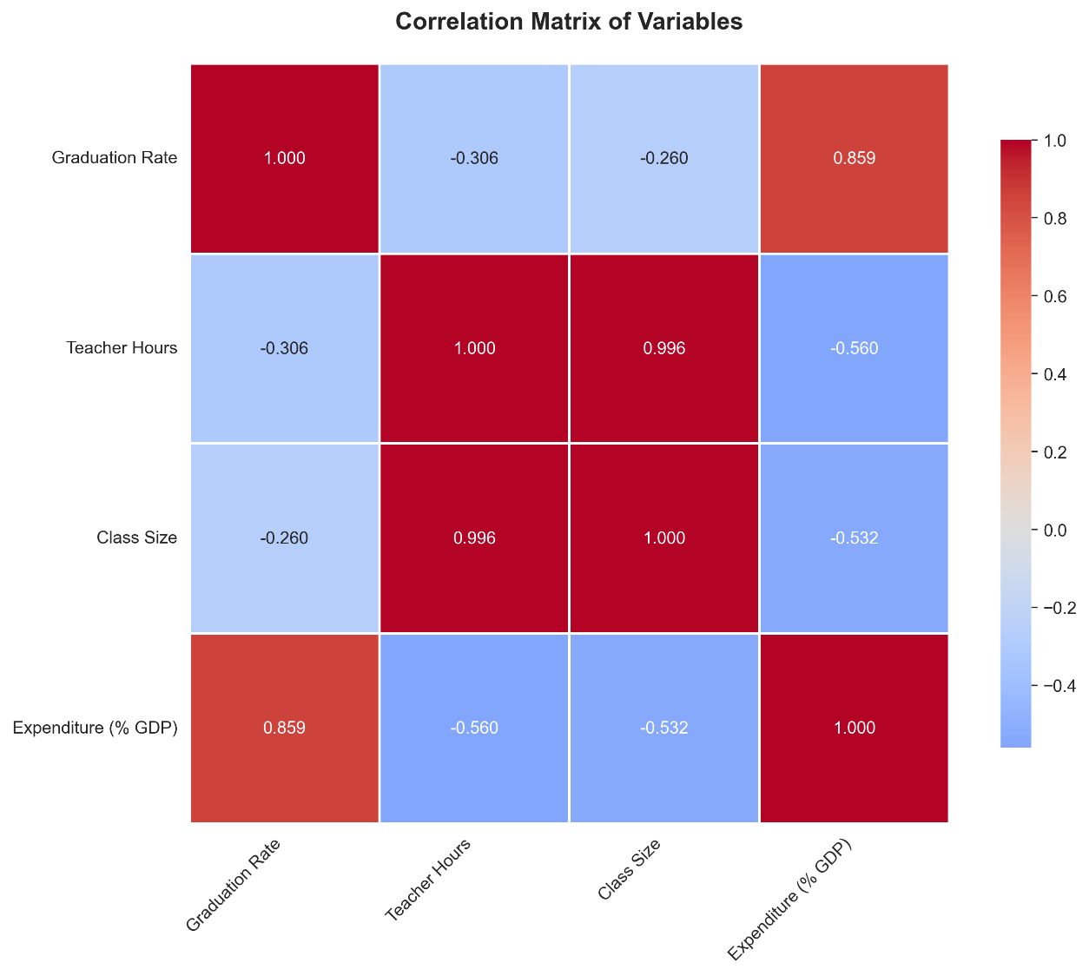

Figure 2: Scatter plots displaying relationships between factors and graduation rates
A clear positive linear relationship supports the relationship findings.
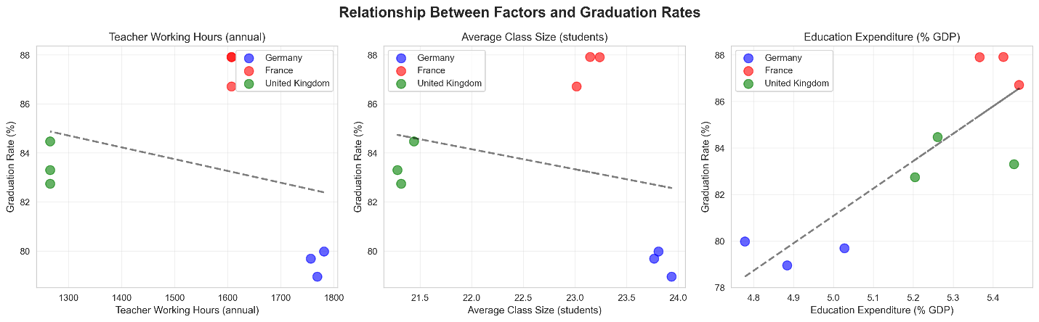
Figure 3: Bar charts comparing average factors across countries
France has the highest expenditure (5.4% GDP) - > highest graduation rates (87.5%)
Germany has the lowest expenditure (4.9% GDP) - > lowest graduation rates (79.5%)
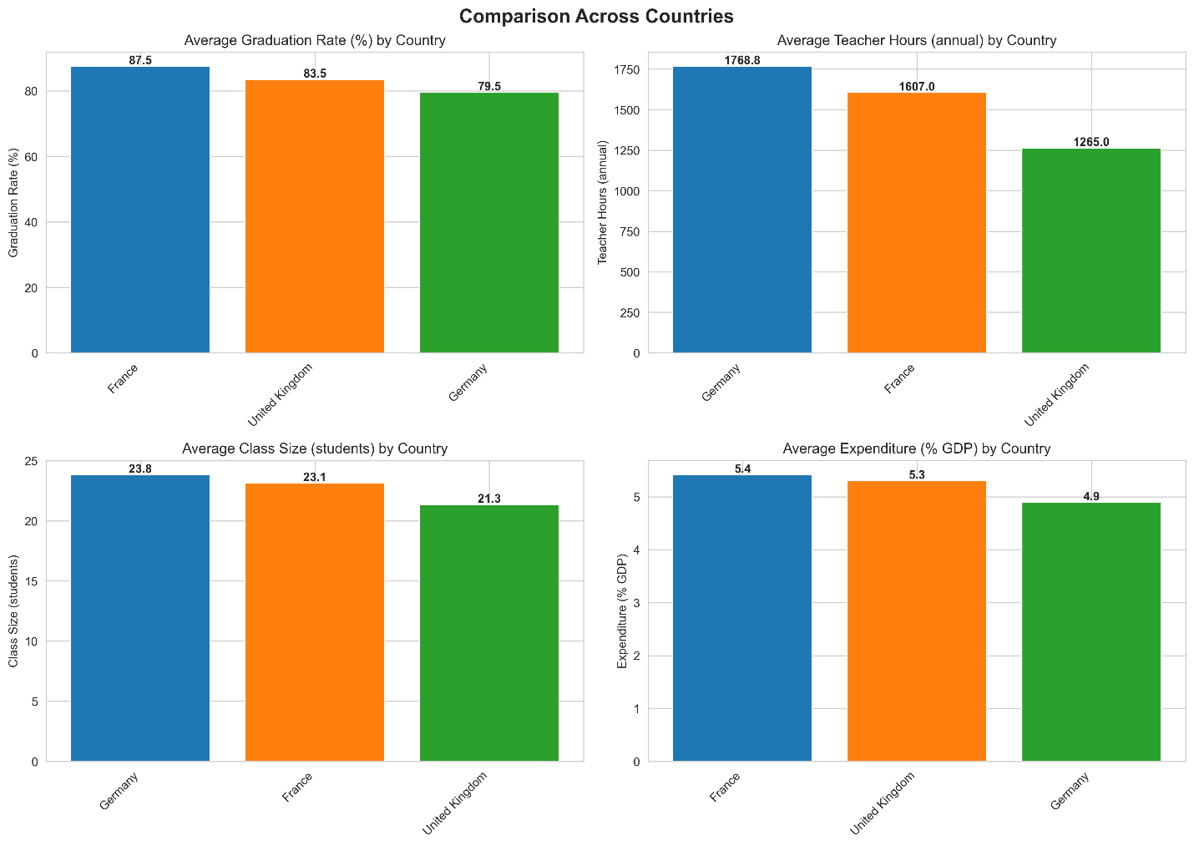
Figure 4: Regression Diagnostics Panels:
Verifies normality of residuals (Shapiro-Wilk p = 0.114), homoscedasticity (random residual pattern), and multicollinearity detected (teacher working hours and class size: r = 0.996)
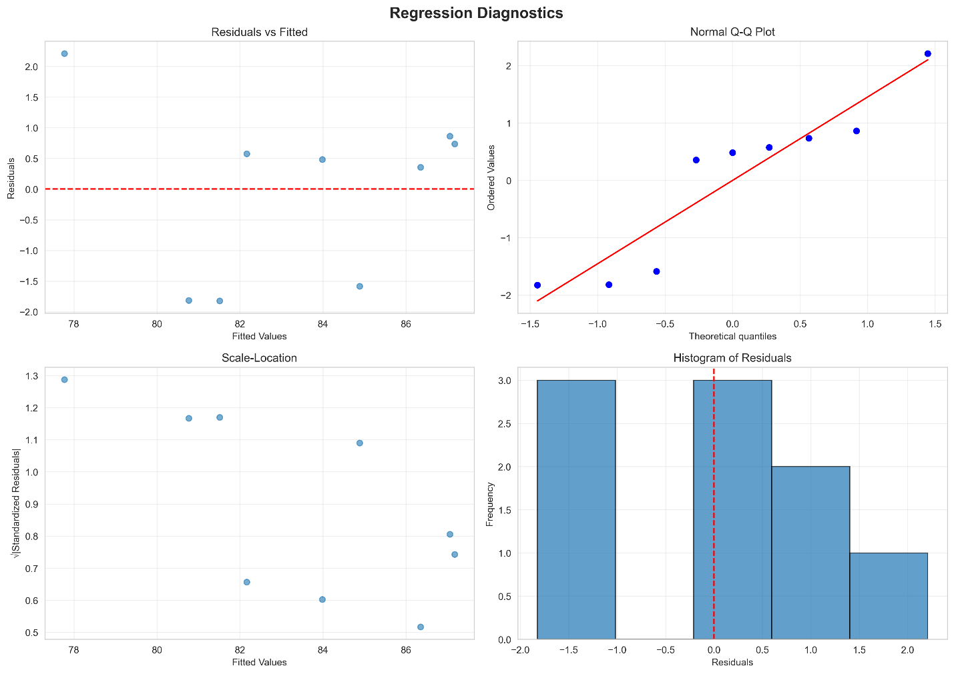

Figure 5: Line graph of secondary education graduation rates by country from 2017-2019
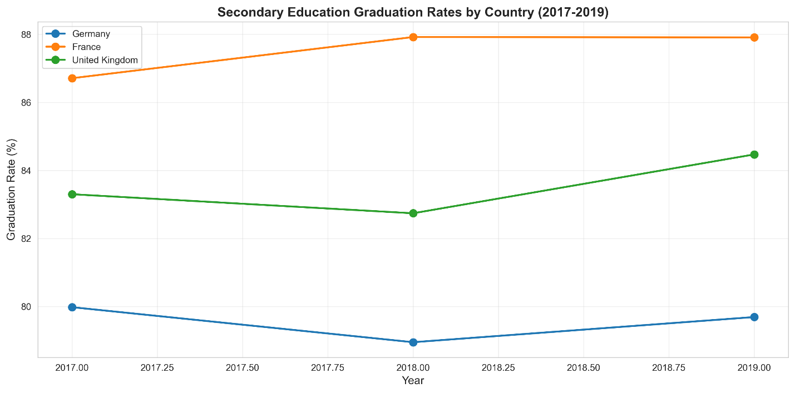
Figure 6: Distribution of variables histogram
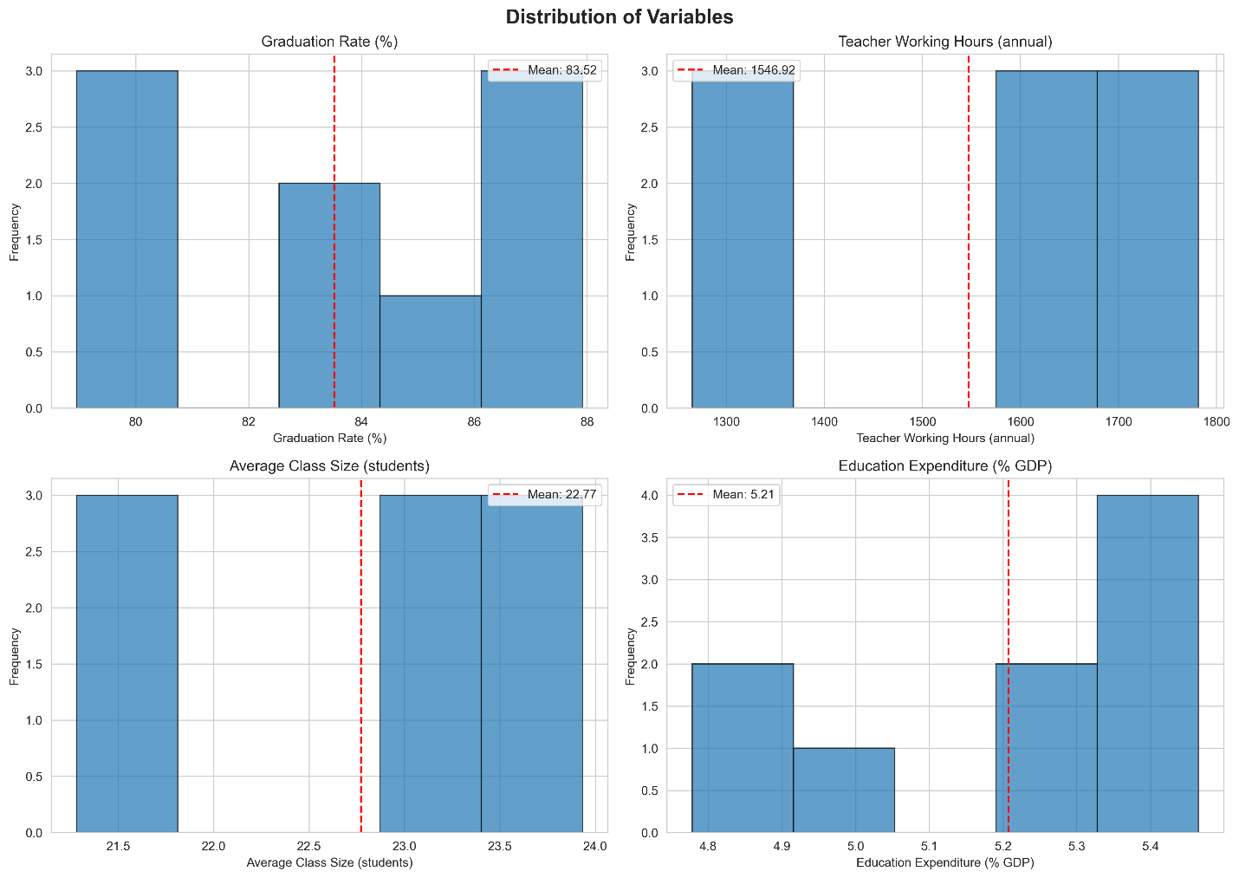

Appendix B

Code Access

The following can be accessed via my GitHub:
- Raw Data: 6 individual datasets
- Cleaned Data: 4 individual datasets, 1 merged dataset
- Results: 6 visualizations, statistical_results.txt
- Scripts (all code): Cleaning_Merging, Analysis
- Written papers: Proposal and Results

